Year 5 Small Grant Research Report to the Disability Research Institute

THE RELATION BETWEEN DISABILITY INSURANCE BENEFITS, THE RESERVATION WAGE AND RETURN TO WORK

Sophie Mitra, Principal Investigator

March 2006

Table of Contents

Acknowledgements.…………………………………………………………….. iii
Abstract ………………………………………………………………………….. iv
Summary………………...……………………………………………………….. v

Introduction ……………………………………………………………………… 1
1. Background…………………….…………..…………………………………….. 4
1.1. SSDI and Return to Work…………………………………………………………. 4
1.2. Continuing Disability Reviews …………………………………………………… 6
1.3. Terminations due to Recovery……………………………………………………. 7
1.4. Literature Review…………………………………………………………………. 9
1.5 Data……………………………………………………………………………….. 11

2. Reservation Wage and Return to Work Analysis…………………….……… 12
2.1. Background on Reservation Wages……………………………………...……….. 12
2.2. Reservation Wage Data…………………………………………………………… 14
2.3. Descriptive Statistics……………………………..……………………………….. 16
2.4. Distribution of the Reservation Wage Ratio………………………………………. 18
2.5. The Reservation Wage Equation………………………………………………….. 21

3. Job Search and Return to Work Analysis……………………………………… 29
3.1. Descriptive Statistics………………………………………………………………. 29
3.2. Job Search and Return to Work……………………………………………………… 32
3.2.a. Empirical Strategy………………………………………………………………… 33
3.2.b. Results…………………………………………………………………………….. 35

4. Recovery Termination and Return to Work………………………………….. 39
4.1 Job Search and Work among those who Recover and those who Do Not…………… 39
4.2 Recovery Termination and Employment Outcomes…………………………………. 40

4.3 Terminated Beneficiaries as a Comparison Group…………………………………… 42

Conclusion ……………………………………………………………………………….. 44
References…………………………………………………………………………………. 50
Tables and Figures……………………………………………………………………… 53
Appendixes……………………………………………………………………………….. 67
List of Tables and Figures
Table 1: Distribution of Reported Reservation Wages
Table 2: Cumulative Distribution of the Reservation Wage Ratio
Table 3: Descriptive statistics and data sources
Table 4: Determinants of the reservation wage
Table 5: Determinants of the Reservation Wage on Sub-Samples
Table 6: Descriptive Statistics on Job Search
Table 7: Tobit Estimates of Job Search Efforts and Probit Estimates of Termination
due to Medical Recovery
Table 8: Probit Estimates of Return to Work Outcomes
Table 9: Terminations due to Recovery and Return to Work

Figure 1: Terminations per 1,000 beneficiaries by reason, 1977-2002
Figure 2: Mean Earnings and Percentage of Persons with Work Earnings by Termination
Status
Figure 3: Start of Job Search and Work Earnings for Terminated Beneficiaries

Acknowledgments: The research reported in this paper was performed pursuant to a grant (10-P-98360-5-05) from the U.S. Social Security Administration (SSA) funded as part of the Disability Research Institute. The opinions and conclusions expressed are solely those of the author and should not be considered as representing the opinions or policy of SSA or any agency of the Federal Government. I have benefited from discussions with Monroe Berkowitz, Debra Brucker, Mark Killingsworth, and insightful comments on an earlier version by Julie Hotchkiss, Douglas Kruse, Scott Muller, David Stapleton and participants of the 2005 annual meeting of the Labor and Employment Relations Association (LERA). All remaining errors or omissions are those of the author.
Abstract:
Using data from the New Beneficiary Data System, this study examines the reservation wages, job search and return to work behavior of a sample of Social Security Disability Insurance (SSDI) beneficiaries. None of the past studies on the reservation wage used data on SSDI recipients. In 1991, 13% of a cohort of beneficiaries who joined the rolls in 1981-82 and did not work since then, report being willing to work if offered a job and their reservation wages. Almost half of these SSDI recipients require a wage that is more than 80% of the last wage earned. A relatively high reservation wage compared to the last wage earned may explain the low return to work rates of SSDI beneficiaries. The report next investigates the determinants of the reservation wage in a regression framework. Non-labor income and whether the person had transitioned to the old age program are key determinants of the reservation wage.
This study also assesses the extent and the determinants of job search efforts, return to work and recoveries among SSDI beneficiaries during the 1980s. The job search and return to work analysis is conducted in two steps. First, I evaluate the effectiveness of job search methods for SSDI beneficiaries. Second, I follow a comparison group approach proposed by Bound (1989) and estimate an upper-bound of the return to work potential of SSDI beneficiaries. Results indicate that none of the search methods used, including state vocational rehabilitation and private employment agencies, has a significant positive impact on employment outcomes and that SSDI beneficiaries still on the rolls appear to under-report their job search efforts. In addition, more than 60% of terminated workers terminated due to a recovery work above the earnings limit following termination.
Summary:
Using data from the New Beneficiary Data System, this study examines the reservation wages, job search and return to work behavior of a sample of Social Security Disability Insurance (SSDI) beneficiaries. The paper has several results of interest.

- The first result of interest is that a significant portion of beneficiaries report being likely to accept a job if offered one. Based on the NBDS, 13% of SSDI beneficiaries who did not work since joining the rolls in 1981-82 reported in 1991 that they would be willing to work if offered a job and reported their reservation wages.
- The second result of interest is that the reservation wages of SSDI beneficiaries are relatively high compared to the last wage earned before joining SSDI. Less than half of them would want a wage that is 80% or less of the last wage earned before getting onto SSDI. Because one would expect that this group on SSDI that has been out of the labor force for several years would suffer a wage cut in order to get a job, their probability to return to work and leave the rolls seems to be limited for this group.
- A third important result of this study is the heterogeneity between persons still on SSDI and those that have moved to the old age program. The sub-samples of persons who have shifted to the Old Age program and those who are still on SSDI have mean reservation wage ratios of 0.91 and 1.38 respectively and the former has a more dispersed distribution. This result was also reached in a regression framework. This heterogeneity between the two groups may result in part from the different incentives both groups face in terms of benefit receipts and work earnings. Longitudinal data is not available to investigate the impact of changes in the earnings limit and benefit offset rate on the reservation wage as persons transition to the old age program.
- A fourth result of interest is that the non labor income beside the benefit is positively associated with the reservation wage while the benefit amount per se is not. This result suggests that reducing the benefit amount may not affect the reservation wage and possibly the return to work behavior of SSDI beneficiaries.
- I also find that13.6% of the sample SSDI beneficiaries report that they searched for a job since joining SSDI. The data also indicate that SSDI beneficiaries may be underreporting their job search efforts.
- Another important result of the job search analysis is that none of the search methods used, including leads from state vocational rehabilitation and private employment agencies, has a significant impact on employment outcomes.
- Finally, I find that more than 60% of beneficiaries terminated due to a recovery work above the earnings limit following termination. Using a comparison group approach, this result suggests that a maximum of 60% of SSDI beneficiaries would work if they were not on the rolls.

THE RELATION BETWEEN DISABILITY INSURANCE BENEFITS, THE RESERVATION WAGE AND RETURN TO WORK

Sophie Mitra

Introduction
The objective of this report is to examine the reservation wages of social security disability insurance (SSDI) beneficiaries, and derive implications for return to work policy. In the labor leisure choice model, the reservation wage is a fundamental aspect of the decision to work or not to work. The reservation wage is the amount a beneficiary would need to earn at work in order to accept a job. For a beneficiary to return to work, the market wage would need to exceed the reservation wage. If return to work is rare among beneficiaries, it may be because beneficiaries are unable to work or because the wages they would earn in the labor market are well below their reservation wages.

This report is at the crossing of two separate literatures. The first one deals with the labor market implications of disability benefit programs. In the 1990s, interest was in part generated by the steady rise of the rolls of the disability benefit programs despite the strong labor demand in the United States (e.g., Autor and Duggan (2003), Stapleton and Burkhauser (2003)). Much of this research was focused on benefit levels, exits from the labor force and screening stringency at the entry into the program. However, growth in the SSDI rolls can also be affected by changes in exit rates, including return to work rates, which is the focus of this paper. Only a few studies have dealt with return to work and have generally focused on worker’s compensation (Butler, Johnson and Baldwin (1995), Galizzi and Boden (2003)).

Secondly, this paper is related to the extensive literature on reservation wages and their determinants: this literature has mainly focused on the reservation wages of the short-term unemployed, on unemployment insurance recipients in particular (e.g., Feldstein and Poterba (1984), Haurin and Sridhar (2003)). Reservation wage data is typically not available for SSDI recipients. Surveys such as the Current Population Survey and the Survey of Income and Program Participation collected reservation wage data for persons who are unemployed. SSDI recipients and more generally, persons who report being unable to work due to a disability are counted as not in the labor force and therefore would not typically be asked to report their reservation wages. This paper uses a unique data set, the New Beneficiary Data System, which has reservation wage data for SSDI beneficiaries. Beside the lack of data, another reason for the lack of research on reservation wages for SSDI recipients is that these individuals have passed the disability test that demonstrates their inability to work above an earnings limit. One may therefore wonder why beneficiaries would have a reservation wage if they are considered as unable to work. SSDI benefit terminations due to return to work (RTW) are rare: in 2003, the recipients that were terminated from the rolls due to return to work stood at 0.5% of the total number of beneficiaries (SSA (2003a)).

However, reservation wages of SSDI beneficiaries are important in the context of return to work policies for the SSDI program. From the establishment of the SSDI program in 1956 until recently, modest return to work policies were implemented and their ineffectiveness was demonstrated (e.g., Hennessey and Muller (1994)). After the passage of the Ticket to Work and Work Incentives Improvement Act of 1999, several programs and experiments were launched and new initiatives to improve the return to work records appeared in the disability plan of the Social Security commissioner (Barnhart (2003)). This recent interest in return to work is not limited to the United States (e.g., Block and Prinz (2001)), nor to disability programs. Several welfare programs around the world have changed in recent years so as to encourage employment and self-reliance among recipients. In the U.S., effective return to work policies may be a way to contain the growth of the disability rolls. The potential savings of return to work policies to the Social Security Trust Fund are large. According to GAO (1999), if an additional 1% of the SSDI and SSI (Supplementary Security Income) working age population were to leave the rolls due to return to work, lifetime disability cash benefits would be reduced by $3 billion.

For disability programs, return to work policies are based on the assumption that there is a pool of beneficiaries who have work capabilities and represent potential labor force returnees. In the SSDI program, disability is defined as follows: “the inability to engage in any substantial gainful activity by reason of any medically determinable physical or mental impairment which can be expected to result in death or which has lasted or can be expected to last, for a continuous period of not less than 12 months” (SSA (2003a)). It is inherently difficult to determine whether or not a person is able to engage in any substantial gainful activity. Two persons may have the same impairment but end up with different work capabilities because of differences in the environments they live in and in unobservables (e.g., motivation). Classification errors are therefore made. Some studies have found that a significant portion of SSDI beneficiaries are not disabled while others who are rejected are disabled (e.g., Benitez-Silva et al (2004), Nagi (1969)).

For these reasons, an investigation of the determinants of the return to work behavior of beneficiaries is warranted, and an analysis of their reservation wages, job search behavior and return to work outcomes is part of this effort. Section 1 includes a review of the policy background and the literature on SSDI and return to work. Section 2 and 3 present the reservation wage and job search analyses respectively. Section 4 addresses the return to work outcomes of beneficiaries who have been terminated due to recovery and the last section of the report presents a summary of the results, policy recommendations and suggestions for future research.

1. Background
1.1. SSDI and Return to Work
Why expect SSDI beneficiaries to seek employment and return to work? A job seeker needs to have work capabilities. While program eligible individuals are considered unable to work beyond an earnings limit at the time they are awarded SSDI, they may search for employment below the program’s earnings limit and stay on the rolls after finding a job. If individuals search for a job above the program’s earnings limit, then finding a job would imply being terminated from the rolls. Termination from SSDI would not take place immediately though. There is first a nine-month trial work period during which the person can earn above the earnings limit and continues to receive benefits. At the end of the trial work period, the beneficiary has a three-year extended period of eligibility during which benefits are withheld for those months when earnings are above the earnings limit. Once the extended period of eligibility is over, the person is terminated from the SSDI rolls due to return to work.

The ability to work above the earnings limit may take place after the individual has spent some time on the disability rolls as employment opportunities in the economy may have changed, or the disability may have been a temporary one. In addition, because it is, in practice, very difficult to determine whether or not a person is able to work, it is likely that classification errors are made and that some persons who are on the rolls are not disabled, while others who are rejected are disabled. Some studies have found that a significant portion of SSDI applicants are not disabled at the time they join the rolls while others are disabled and yet are rejected (e.g., Benitez-Silva et al (2004), Nagi (1969)). With the termination of benefits once beneficiaries work above the earnings limit and generous earnings replacement ratios, there is an incentive for SSDI beneficiaries who are capable of working not to work or to work below the earnings limit.

Beyond benefit levels, there is another policy tool that may affect a beneficiary’s job search efforts and work outcomes: the supply of free vocational rehabilitation services. Vocational rehabilitation services are available to a wide range of persons with disabilities, including some SSDI recipients and denied applicants. These services have traditionally been provided by state public agencies. Not every SSDI recipient is eligible for vocational services, one needs to be selected into the services and eligibility criteria vary from state to state. Vocational rehabilitation services include physical therapy, general education, job counseling, job training and job placement. Job placement services provided by vocational rehabilitation agencies can be considered as a method used as part of a job search.

Starting in 2002, SSA rolled out the Ticket to Work and Self-sufficiency program (Ticket to Work), which allows SSDI and SSI beneficiaries who have been given return to work ‘tickets’ to redeem their tickets with a vocational rehabilitation and other employment service provider of their choice among an array of approved public and private providers referred to as employment networks. The program is voluntary and was phased in nationally over a three-year period. Before the Ticket to Work program, SSA would reimburse state vocational rehabilitation agencies for services provided to beneficiaries if the beneficiary achieved earnings above SGA for at least nine months after the completion of services, subject to certain payment limits. Under Ticket to Work, state vocational rehabilitation agencies can continue to use this traditional payment system, but they may opt to use one of two new payment systems that have much stronger incentives tied to exit from the SSI and SSDI rolls. Further, they must now compete with private providers, which are eligible to use either of the new payment systems, but which are not eligible to use the traditional system.

1.2. Continuing Disability Reviews
A beneficiary may be terminated from the SSDI after demonstrating a recovery following the completion of a trial work period and the extended period of eligibility. In addition, a beneficiary may be terminated after being assessed as having recovered as part of a ‘continuing disability review’ (CDR). After deciding that an individual has a disability, SSA is required under the Social Security Disability Amendments of 1980 to evaluate the impairment to determine whether or not the disability continues. To fulfill this obligation, SSA conducts a CDR, which may lead to terminations from the rolls.

During a CDR, the beneficiary is asked to provide information about any medical treatment he or she has received and any work he or she might have done. A team comprising a disability examiner and a doctor will determine whether the person is still disabled and should stay on the rolls. If they decide that the person is no longer disabled and is to be terminated, benefits stop three months after the beneficiary is notified of the termination (SSA (2003a)).

CDRs can be triggered in two different ways, and reference is made below to ‘medical’ and ‘work’ CDRs to differentiate the two. A medical CDR takes place from time to time depending on the severity of the impairment and the likelihood of improvement (SSA (2003a)): (i) if improvement is expected, then a first review will take place six to 18 months later; (ii) if improvement is possible, the review will take place about every three years; (iii) if improvement is not expected, the case will be reviewed only five to seven years later.

Work CDRs are triggered by different types of events, which are described in detail in GAO (2004). Most work reviews are generated by Social Security’s review enforcement operation, which involves periodic computer matches between Social Security’s administrative data and Internal Revenue Service wage data. When earnings exceed a specified threshold, then a work review takes place. Work reviews can be triggered by other events such as reports from state vocational rehabilitation agencies or anonymous tips. It is also possible that as part of the medical review, evidence is found that the person may be working, thus prompting Social Security to conduct a work review.

1.3. Terminations due to Recovery
Until 2002, SSDI benefit terminations following work and medical CDRs were recorded together in SSA administrative data system. In this paper, I refer to terminations following work and medical CDRs under the umbrella term of ‘termination due to recovery’.

Terminations due to recovery typically account for less than 10% of all terminations (SSA (2003b)), most terminations in fact result from death or transitions to the Old Age program. However, as shown in Figure 1, the percentage of all terminations that are due to recoveries has greatly changed over the years. During the 1980-1983 period, between 35 to 60% of all terminations resulted from recoveries. This was an unusual period, after which most terminated workers were reinstated. Typically, due to limited resources dedicated to CDRs, not all CDRs are carried out and terminations due to recoveries are a small portion of all terminations.

Evaluating the incentive effect of benefit termination is complicated given the likely endogeneity of, on the one hand, the job search and return to work decision, and on the other, the benefit termination process. In other words, the benefit termination process could be internal to the return to work process. Because an individual has searched and found a job and worked, he or she may end up being terminated following a ‘work’ CDR or the completion of the extended period of eligibility. At the same time, because an individual is terminated following a ‘medical’ CDR and stops receiving benefits, he or she has different costs of search compared to a person still on SSDI, which influences the decision to search for a job and return to work.

Work CDRs, by giving the clear signal that work activity can trigger a review and thereafter a termination, may work as an incentive not to work. In fact, CDRs have been perceived as providing work disincentives and the Ticket to Work and Work Incentives Improvement Act of 1999 (section 111) has provided that effective January 1, 2002, a return to work alone cannot trigger a review of the beneficiary’s disability for DI beneficiaries who have received benefits for at least two years. In other words, CDRs are limited to medical CDRs from 2002.

1.4. Literature Review
In the return to work literature on SSDI beneficiaries, some results can serve as a rationale and as a point of reference for this study. The literature has first of all shown that a significant portion of beneficiaries work: more than one in four beneficiaries work after benefit entitlement albeit only 10% of all beneficiaries are considered as substantial workers (Ycas (1996), Muller (1992)). Worker characteristics have been found to influence return to work propensity. Several studies have shown that as workers age, they are less likely to return to work, and that workers with more education are more likely to go back to work (Muller (1992), Hennessey (1997), Schechter (1997)). On the labor demand side, differences in employers’accommodation policies across industries and accommodations were shown to influence the return to work propensity of SSDI recipients (Schechter (1999)). Regarding programmatic factors, beneficiaries are in large majority unaware of work incentives such as the trial work period (Hennessey and Muller (1994)). The use of vocational services was shown to have a positive small impact on return to work propensity in Hennessey (1997), although Hennessey and Muller (1994) found that SSDI beneficiaries who went back to work reported that vocational rehabilitation did not help. As for job search, Hennessey and Muller (1994) found that beneficiaries report that they search for a job primarily due to financial need and Schechter (1997) showed that they typically use three main job search methods: asking a friend, checking ads and contacting employers.

The above studies on SSDI and return to work conducted by SSA researchers did not address three issues of interest. Firstly, they did not assess the magnitude of the reservation wages of SSDI beneficiaries, perhaps in part due to the lack of reservation wage data for persons with work disabilities.

Secondly, the studies did not attempt to evaluate the effectiveness of different job search methods. They ignore that the access to different job search methods may be unevenly distributed and that the relative effectiveness of alternative search methods may differ. There is a large literature in economics on job search methods among the short term unemployed. It has long been recognized that the informal channel of friends and relatives is the most effective to find jobs (Holtzer (1988)). The ineffectiveness of other routes such as public employment services has been demonstrated (e.g., Addison and Portugal (2002)). These results are for the short-term unemployed in general, and Hotchkiss (2003; p. 119) showed that they also applied to all persons with disabilities. It is important to determine whether certain job search strategies are more effective in leading to employment for SSDI beneficiaries. The recent Ticket to Work program has recently given priority to encourage return to work by offering beneficiaries the choice to use a variety of employment service providers where they can redeem a so-called ‘Ticket’. Employment service providers can be the traditional state vocational rehabilitation or other public employment agencies, private employment agencies or community rehabilitation agencies. It is essential to find out if beneficiaries and employment service providers rely on the most effective job search strategies.

Finally, the above studies on SSDI and return to work have given little attention to the relation between terminations due to recovery and return to work. Only Muller (1992) analyzes the propensity to return to work and to have benefits terminated due to sustained earnings above the earnings limit. In particular, little is known on the impact of the incentives of SSDI receipt on return to work. This study attempts to contribute to fill these gaps in the literature on SSDI and return to work and uses the same data set as many of the studies referred above on SSDI and return to work (e.g., Henessey and Muller (1994)), the New Beneficiary Data System.

1.5. Data
The data source is a panel survey of the Social Security Administration, the New Beneficiary Data System (NBDS). The NBDS is a unique data set with a wealth of information on the post entitlement work efforts of SSDI beneficiaries. It is based initially on a nationally representative cohort of new beneficiaries who joined SSDI in 1980 and 1981, and were interviewed in 1982 as part of the New Beneficiary Survey (NBS). NBS respondents were re-interviewed as part of the National Beneficiary Follow-up (NBF) survey in 1991. I focus below on beneficiaries who responded to the NBS in 1982 and to the NBF in 1991 and I use data from the three different parts of the data system: the NBS, the NBF and administrative records. Administrative records include Social Security earnings and benefits records and records from the then Health Care Finance Administration. Some of the characteristics of the data set, including its limitations, are reviewed in detail in sections 2 and 3 below with specific references to reservation wage and job search data.

2. Reservation Wages and Return to Work Analysis
2.1 Background on Reservation Wages
In the literature, the term “reservation wage” has been used with two different meanings. In the labor supply literature (Killingsworth (1983)), it has been used as the lowest wage at which a person will work, which has also been referred to as the “asking wage”. It is the slope of the person’s indifference curve at zero hours of work. In the job search literature, the term refers to the lowest wage a person would accept if the person has to pay a positive sum to gain another job offer from a wage distribution (e.g., Mortensen (1986)). In this paper, the reservation wage is used in the sense of the labor supply literature.

I assume that there is a pool of beneficiaries who have work capabilities and represent potential labor force returnees. If a person has a disability, there is no finite wage rate that would make a person take up a job. If the person has work capabilities, there exists a finite wage rate (w*) for which the person would go back to work. That is, the person would accept jobs paying w* or more. Based on Burdett and Mortensen (1978), I formulate the return to work probability for a given beneficiary i as follows:
$p_{i,1}=α_{i}s_{i}F_{i}(w_{i}∗)$ (1)
where $α_{i}$ is the offer arrival rate, and $s_{i}$ the time allocated to job search $0≤s_{i}≤1$. A job is characterized by a wage $\tilde{w}$, which is a random draw from the wage distribution F.
If person i has a disability and is unable to work, then $F_{i}$ is null for an infinite $w_{i}∗$ and the return to work probability is null. If person i is able to work for a finite wage $w_{i}∗$, then $F_{i}(w_{i}∗)>0$. In this case, $p_{i,1}$ may be null if the labor market is such that she has little chance to find a job at a wage rate equal or beyond the reservation wage ($α_{i}F_{i}(w_{i}∗)=0$) or if the person does not search for a job ($s_{i}$=0). The time dedicated to job search s_{i} is expected to be determined by the time constraint placed by the disability. For some disabilities, the time that has to be dedicated to self-care may be substantial. In addition, the individual’s preferences with regard to work and leisure and budget constraint (nonlabor income and earnings of the individual and other members of the household) would also influence the amount of time dedicated to job search. Finally, the time dedicated to job search is determined by the individual’s expectations with regard to the offer arrival rate and the offer wage distribution.

The person may return to work but stay on the rolls if his or her work earnings are below the earnings limit (g). The reservation wage can be below g, in which case the person could accept a job below g and stay on the roll, or above g and leave the rolls. A reservation wage above g would indicate that the person would only accept a job that would ultimately make her ineligible for SSDI. The probability that person i exits the rolls is as follows:
$p_{i,2}=α_{i}s_{i}F_{i}(g)$ (2)
If $w_{i}∗g$, $p_{i,1}=p_{i,2}$ . If $w_{i}∗g$, then $p_{i,1}>p_{i,2}$, and the probability of returning to work while staying on the SSDI roll is $p_{i,1}−p_{i,2}$. According to the above formulation, the SSDI exit probability is a function of the following parameters ($α_{i},s_{i},F_{i},w_{i}^{},g$), where$α_{i}$and $F_{i}$reflect conditions of the labor market. Some of the above parameters can be influenced through public policy, directly (g) or indirectly ($α_{i},s_{i},F_{i},w_{i}^{}$). First of all, whether the reservation wage is finite or not (in other words whether the person has work capabilities or not) depends on the disability tagging system in place and how frequently classification errors occur. It is also important to note that a beneficiary may well have a finite reservation wage while no classification error has been made simply because the criteria to get on the rolls are different from those to stay on the rolls (CDRs). Once someone is on the rolls, they can stay on the rolls if they do not work and their disability continues. Whether they are able to work is not reassessed unless they are expected to recover or actually work.

In addition, policies that encourage beneficiaries to participate in return to work services, as in the recently implemented Ticket to Work program, can have an impact on $s_{i}$ by encouraging persons to search for a job through services like job counseling. Such services can also improve the person’s wage offer distribution $F_{i}$ if they enhance the human capital of the beneficiary and thus give prospects for improved wages. They can also increase the person’s offer arrival rate ($α_{i}$) through job search coaching services. In this context, return to work policies may be evaluated in their ability to boost $α_{i}$, $s_{i}$and $F_{i}$ for those beneficiaries who have work capabilities.

A return to work policy will aim to increase the reemployment probability and the SSDI roll exit probability of every person who is on the roll and has some work capabilities. The above formulation illustrates how the reservation wage is a determinant of the return to work and exit probabilities of a beneficiary and how it therefore is an important variable in the context of return to work policies. It is therefore of interest to examine the reservation wages of SSDI beneficiaries.

2.2. Reservation Wage Data
All NBF respondents were asked if they “worked for pay either part time or full time” after the month they started receiving Social Security Disability benefits. Those beneficiaries who reported that they never worked since joining the rolls were asked the following: ‘If you were offered a job by some employer in this area, how likely would you be to take it?’. Individuals had to answer by yes or no to the following: ‘yes, definitely’, ‘yes, if it were something you could do’, ‘yes, if the wages were satisfactory’, ‘yes, if the location was satisfactory’, ‘yes, if the hours were satisfactory’, and finally ‘yes, for some other conditions’.

Individuals who gave at least one yes answer to the above conditions were then asked to provide their reservation wages as follows: “What would the smallest wage or salary have to be for you to take a job offered by some employer?” Respondents had to give a dollar amount and specify the time unit the amount referred to (year, month, week, day, or hour).

In this report, subjective reservation wage information is thus used, as has been done in several instances in the literature (e.g., Bloemen (1996)). A lot of caution is needed while using such data. Indeed, while the reservation wage is a simple concept, measuring it is difficult. One way wonder if individuals really have reservation wages and if the reservation wages they report are reliable.

One caveat of the dataset is that respondents were not asked to report the desired number of hours or days worked. One possibility would be to use observed working hours in the last job or in the longest employment before getting onto SSDI: however, this number of hours worked is likely to have been affected by the onset of a disability. One implication of this caveat is that the interaction between the reservation wage and the number of hours worked, i.e. the potential endogeneity of hours, cannot be accounted for as has been done elsewhere (Bloemen (1996)). Another caveat is that reservation wages are not strictly comparable across respondents who used different time units.

Another important caveat of the data set is that it suffered from a significant attrition between 1982 and 1991. Antonovics, Haveman, Holden and Wolfe (2000) showed that at the 1991 re-interview, 39% of the SSDI beneficiaries had been reduced from the sample due to attrition, of which 30.8% can be attributed to death. Antonovics, Haveman, Holden and Wolfe (2000) found that gender, age, marital status, education and specific health conditions are significantly associated with the likelihood of attriting due to death and due to other reasons. The sample of workers who may have answered the reservation wage question in 1991 is therefore no longer representative of the initial cohort of new beneficiaries and the results of the analysis below may be affected by a nonrandom attrition bias. Because of the possible attrition bias, results from the analysis in this paper are applicable to beneficiaries who have been on the rolls for several years more than newly enrolled ones.

Another limitation of the data is that the reservation wage question was not asked among persons who worked at some point since joining the rolls. These beneficiaries might have had work capabilities at the time of the survey in 1991 and it would have been of interest to know their reservation wages. At the same time, it could be argued that the sample of reservation wage respondents is the group of beneficiaries who are of much interest from a return to work policy perspective: these beneficiaries have stayed for a long time on the rolls, have work capabilities and yet have not worked since becoming beneficiaries. If the return to work rate of SSDI beneficiaries is to increase, this group is certainly where there is potential for improvement in return to work outcomes.

Out of the 3,161 SSDI beneficiaries who joined the rolls in 1980 and 1981 and responded to the NBF in 1991, 529 reported that they worked for pay either full time or part time since joining the rolls. The remaining 2,632 did not work for pay, and 345 (13%) of them reported that they would be likely to accept a job if they were offered one and reported their reservation wages.

2.3 Descriptive Statistics
Table 1 shows the distribution of the reservation wage in 1991 dollars for the 345 reservation wage respondents on an hourly, weekly, monthly and annual bases. Seventy four percent of respondents provided a reservation wage on an hourly basis and 10%, 8% and 8% on a weekly, monthly and annual basis respectively. Only two respondents provided a daily reservation wage, $10 and $20 respectively, which is not given in Table 1. The last row of table 1 gives the number of persons whose last job before receiving SSDI was a full time job: the large majority of reservation wage respondents were full time workers before getting onto SSDI, which will be useful to know while calculating the reservation wage relative to the last wage earned ratio.

The population under study includes unemployed individuals who were determined to be disabled when they applied for SSDI and who have not worked since joining the rolls 10 years earlier, in 1980 and 1981. Most investigations on the reservation wage have used reported reservation wages for the short-term unemployed, typically recipients of unemployment insurance (e.g., Jones (1988)). Before proceeding with the analysis of the determinants of the reservation wage, it is important to check the consistency of the data of these persons not in the labor force. I first compare the reservation wage to the minimum federal wage in 1991, i.e. $4.25 per hour (I use $180, $774 and $9,288 for the equivalent weekly, monthly and annual minimum wages). A large portion of the respondents who reported a reservation wage on an hourly basis had a reservation wage close to the minimum wage: 31% has a reservation wage at $4, 25% at $5 and 11% at $6. This was not the case for respondents who used other time units: the large majority of respondents had reservation wages largely above the federal minimum wage. Overall, only 8.6% of all reservation wage respondents had a reservation wage that was 90% or less of the federal minimum wage.

I also compare reported reservation wages with benefit amounts. For that purpose, the reservation wage amounts were transformed into monthly wages on the basis of 40 hours of work per week, 4.3 weeks per month, and 20.5 working days per month. I compared the means of the reservation wage and of the monthly family benefit amount. The mean reservation wage is $1,209 per month and the mean family benefit amount is $822 per month. Because an individual would typically expect to have a higher income when he/she works than when he/she does not, the reported reservation wages seem to be reasonable. Overall, despite the caveat of not having expected working hours or days, I conclude that the subjective reservation wage data reported in the NBDS is of reasonable quality and I proceed with its analysis.

2.4. Distribution of the Reservation Wage Ratio
Of particular interest in the analysis below is the ratio of the reservation wage and the last wage earned before getting onto SSDI. It ranges from 0.03 to 21.27. After removing individuals for whom the last wage earned is missing, I end up with a sample of 313 SSDI beneficiaries. The data for the last wage earned before tax prior to getting on SSDI was collected in 1981 as part of the NBS and was converted into 1991 dollars. The analysis below builds upon past analysis of this ratio developed by Feldstein and Poterba (1984) and used by Jones (1989, 2000) and Ryscavage (2002).

Table 2 gives the mean and distribution of the reservation wage ratio for the whole sample and for several sub-samples. For the whole sample, the mean ratio is 1.17 with some strong variations by sub-sample. Females and persons who are still on SSDI have the highest mean ratios, 1.38 and 1.91 respectively. The sub-sample with the lowest mean ratio is that of individuals who have shifted to the old age program. The median reservation wage represents 84% of the last wage earned.

Turning now to the distribution of the ratio, almost two thirds of the whole sample are ready to accept a wage reduction. This is shown as the cumulative portion of 60% who are ready to work at a wage equal to or less than their last wage earned before getting on SSDI. Among the sub-samples, the distributions that are the most dispersed are those of persons who have transitioned to the old age program, those of females and of persons who have had an accident on the job.

The sub-samples of persons who have shifted to the Old Age program and those who are still on SSDI show strong differences, with median ratios of 0.72 and 0.99 respectively and a more dispersed distribution for the former. Indeed, 40% of individuals now on the old age program are ready to work for 60% or less of the last wage earned compared to 24% of the persons who are still on SSDI. Such differences between these two sub-samples may result in part from the different earnings disregards and implicit tax rates these two sub-samples have. SSDI beneficiaries whose work earnings are above the earnings limit of $500 per month in 1991 have their benefits terminated. In the old age group, persons aged 65 to 70 have their benefits reduced by $1 for every $3 earned above $9,720/year and persons aged 70 or older are not subject to any earnings limit (SSA (2003a)). In addition, these two groups face different conditions regarding their Medicare coverage. Persons on the old age program are entitled to Medicare irrespective of their work status, whereas persons who are still on SSDI would lose Medicare after going back to work above the earnings limit.

It is of interest to compare the above results with those of studies on unemployment insurance recipients. First, the distribution of the reservation wage ratio overall is close to those of these studies. Feldstein and Poterba (1984) and Jones (1989) found that 62% and 56.5% of the unemployed have reservation wages that are lower or equal to their last wages earned in the U.S. and in the U.K. respectively, compared to 60% for SSDI beneficiaries. In addition, an interesting finding is that the mean of the reservation wage ratio is equal or higher for SSDI recipients (1.17) than for unemployment insurance recipients: 1.07 (Feldstein and Poterba (1984)), 1.045 (Jones (1989)), 0.85 in Jones (2000), and 0.83 (Ryscavage (2002)). This may be explained by the fact that persons on SSDI receive a permanent benefit, whereas persons on unemployment insurance receive a temporary one. Also, persons on SSDI have physical or mental impairments that may affect the way they value leisure versus work, which may have a positive impact on the reservation wage.

One can gauge the return to work probability of a beneficiary only by comparing the reservation wage to the person’s wage offer distribution, which is unknown here. If the last wage earned before getting onto DI is used as a proxy for the mean of the current wage offer distribution, then the reservation wage ratio distribution given in Table 2 provides estimates of the wage offer distribution $F_{i}(w_{i}∗$).

One may expect that SSDI beneficiaries would have to suffer a wage reduction if they go back to work. The impairment itself can be the cause of a wage reduction. Past research has shown that wage reductions following the onset of a disability can be substantial. Burkhauser and Daly (1996) showed that the median drop in earnings between one year before the onset of a disability to two years afterward was 31% for men and 61.7% for women. Baldwin, Zeager and Flacco (1994) showed that wage losses following a disability onset vary substantially by type of impairment and by gender. In addition, persons on SSDI have been out of the labor force for some time, the beneficiary’s skills and productivity may have deteriorated, and there may have been a change in production methods that makes remaining skills less valuable. Together with the possible perception of reduced productivity and discrimination among potential employers with respect to persons with disabilities, this would suggest that the mean wage offer would lie below the last wage earned. If it stands at 80% of the last wage earned then, based on Table 2, only 39% of the sub-sample of beneficiaries who are still on SSDI would have a reservation wage above the mean wage offer, and 55% of those who have transitioned to the old age program.

All in all, results of the reservation wage ratio analysis and the likely wage reduction that SSDI beneficiaries would point toward a limited probability of return to work for SSDI beneficiaries with work capabilities and may explain why return to work rates are low for SSDI beneficiaries. Recent and ongoing return to work programs typically have attempted to increase the job offer arrival rate, the time spent on job search and the wage offer distribution through the provision of reemployment services (counseling, job search coaching, vocational training). It is for instance the case of the Ticket to Work program, currently under way. Policies may also affect the reservation wage itself, e.g. via benefit levels. To investigate this issue, I now turn to an analysis of the reservation wage in a regression framework.

2.5. The Reservation Wage Equation
This section deals with the determinants of the reservation wage. Of particular importance is the amount of SSDI benefits and the amount of other non-labor income received. A well-known prediction of the labor-leisure choice model is that the reservation wage increases with non-labor income. Higher SSDI benefits should therefore increase the reservation wage. The dependent variable is the log of the reservation wage.
$\text{log}{\text{RW}}_{i}=α_{1}+δ_{1}X_{1,i}+ε_{1,i}$ (3)
Only beneficiaries with work capabilities have finite reservation wages. However, reservation wages are available only for a selective sub-sample of the cohort of beneficiaries with work capabilities, which can lead to the biased estimation of coefficients. It is not available among beneficiaries who worked since joining the rolls. The data are “selected” by a systematic process, that is accounted for through the well-known technique developed by Heckman (1979). For inferences from estimating equation (3) on a sub-sample of persons reporting their reservation wages to be generalizable to the entire cohort of beneficiaries with work capabilities, the estimation needs to take into account a beneficiary’s propensity to report their reservation wages. This propensity can be represented as an indicator function:
$I_{i}=1$if ${\text{RW}}_{i}>0$
$I_{i}=0$ otherwise (4)
I first estimate a probit model that explains the response or absence of response to the reservation wage question.
$I_{i}=α_{2}+δ_{2}X_{2,i}+ε_{2,i}$ (5)
A sample correction variable (the inverse Mills ratio) is created to account for the fact that the sample of respondents is not random. This variable is then included as an explanatory variable in the reservation wage equation (3) to correct for sample selection bias. The two vectors $X_{1,i}$and$X_{2,i}$ may be different but need not be. In this application, they include the same variables except the number of limitations in activities of daily living that is in the former but not the latter.

Table 3 gives the descriptive statistics for the variables used for the whole sample, and for the sub-samples of persons who are still on SSDI and those who have transitioned to the old age program. All variables were collected in 1991 as part of the NBF and administrative data except for race and information on the last job held (lost job, accident on the job, the last wage and occupation) which were collected in 1982 as part of the NBS. The log of the benefit is the log of the family benefit amount, which includes payment to the beneficiary and dependents. A variable is used for self-reported non-labor income other than the SSDI benefit. Beneficiaries in the NBF are eligible for Medicare, since they have been on SSDI for more than two years. A dummy indicates whether the person reports having a health insurance coverage in addition to Medicare in order to assess the potential impact that health insurance coverage may have on return to work. Other health insurance may include Medicaid, Champus, a military coverage or any other health insurance coverage. Relevant demographic variables include the individual’s age, race, gender, marital status and education. Education is measured by the number of years of schooling. Dummy variables indicate whether the person used vocational rehabilitation, has one or more limitation in activities of daily living, has lost the last job or has had an accident on the job, has specific health conditions and what type of occupation the person had in the last job before getting onto SSDI. This data set does not include information on the states or the regions where respondents live.

Results for the sample selection bias on reservation wage response are available in the appendix. Sample size for the probit estimation is 454 of which 323 individuals have responded to the reservation wage question. Gender, age, the use of vocational rehabilitation services, health insurance coverage, whether the person lost the last job held before joining SSDI and the number of activities of daily living were found to be significant determinants of responses to the reservation wage question.

Results for five specifications of the reservation wage are presented in Table 4. In all specifications, the coefficient of the log of the monthly other income is positive and significantly different from zero: the coefficient of 0.299 in (a) indicates that an increase in the log of the benefit by 10% would increase the log of the reservation wage by 2.99%. This result gives support to the prediction of the labor-leisure choice model that there is a positive relationship between non-labor income and the reservation wage. However, the log of the benefit amount has a coefficient that is close to zero in all specifications. In this case, the impact of the SSDI benefit amount on the reservation wage is found to be less important than that of other non-labor income, which includes the spouse’s earnings and other benefits received. This result adds to the reservation wage literature. Earlier studies (Feldstein and Poterba (1984), Jones (2000), Sandell (1980), and Gorter and Gorter (1993), Bloemen and Stancanelli (2001)) found a positive relationship between reservation wages and unemployment insurance benefits. One exception is Jones (1989), who found a negative relation. An advantage of this study is the use of administrative data for the benefit amount and while earlier studies on the reservation wage relied on self-reported benefit data.

In all specifications, the accident on the job dummy has a coefficient that is positive and significantly different from zero indicating that persons who have had an accident on the job would require a higher wage. In addition, the sample selection bias variable (Rho) has a coefficient that is not significantly different from zero, which indicates that the model does not suffer from selection bias. Other results vary across specifications.

In specification (a), the age variable has a negative coefficient close to zero. This result appears counter-intuitive as one expects persons to value leisure versus work increasingly as they age and is at odds with results of other studies showing a positive association between the reservation wage and age (Jones (1989), Bloemen and Stancanelli (2001)). Being married is associated with lower reservation wages. Other variables have coefficients that are close to zero: these include race, other health insurance coverage, education, and having lost the last job.

In specification (b), the age variable is replaced by a dummy that indicates if a person has transitioned to the Old Age program, the coefficient is negative as previously for age but its absolute value is higher at 0.113 ( vs. 0.004 for age in (a)) and is significantly different from zero. This result may indicate that it may not be age per se that influences the reservation wage but the different sets of incentives that persons who are still on SSDI and persons who have transitioned to the old age program face in terms of benefit offset rates and earnings disregards.

The log of the past wage is introduced in specification (c): it has a positive coefficient of 0.090 that is significantly different from zero. However, this result does not hold consistently across specifications. Occupations in the last job are introduced in specification (d). Having a last job in clerical or construction work significantly increases the log of the reservation wage. Specification (e) includes dummies for specific health conditions instead of the number of health conditions. Having a bone or a muscle condition reduces the log of the reservation wage by a coefficient of 0.135 while having a heart condition increases it by 0.126.

Specification (a) of the regression was run on sub-samples of persons still on SSDI and persons now on the Old Age program. Results are in Table 5. It is interesting to note that the log of other non-labor income has a larger coefficient for persons on SSDI (0.309) than for persons on the old age program (-0.015). The age dummy is close to zero in both sub-samples. The number of health conditions has a small coefficient in both sub-samples, but is positive for persons still on SSDI and negative for those now on the old age program. The coefficient of the sample selection variable (Rho) is significantly different in the Old Age sub-sample, which indicates that results from this specification need to be used with caution.

3. Job Search and Return to Work Analysis
3.1. Descriptive Statistics
Table 6 gives summary statistics on the individual characteristics, search choices and work outcomes of the whole sample, and for three subgroups of the sample that had different beneficiary status in 1991: persons who have been terminated from SSDI due to recovery, persons who are still on SSDI and those who have shifted to the old age program.

First, Table 6 provides information on the number and percentage of the cohort of new beneficiaries who search for a job and who had positive work earnings between 1981 and 1991. I find that overall, 13.6% of respondents have searched for a job since they became SSDI beneficiaries in 1981 or 1982: 65.1% of persons who have been terminated from SSDI due to recovery, 16.2% of persons still on SSDI and 9.8% of beneficiaries who have shifted to the old age program reported that they did search for a job since becoming a beneficiary.

In addition, 21.1% of the cohort had some work activity while on the rolls, and only 13.6% reported that they searched for a job. It may be that some beneficiaries received unsolicited offers and returned to work. At the same time, it may indicate that SSDI beneficiaries under-report their job search activities. This makes sense given that any work related activity may be the trigger of a ‘work’ CDR and lead eventually to benefit termination. The likely under-reporting of job search efforts stands in contrast to those on Unemployment Insurance recipients who have been shown to over-report their job search efforts (St Louis, Burgess and Kingston (1986)). This issue of job search underreporting deserves further research.

Thus overall, work and job search are important activities for SSDI beneficiaries and a significant portion of SSDI recipients are in the labor force at some point after joining the rolls. This is an important finding given the large size of the SSDI program with 8.49 million beneficiaries in 2003.

Relevant demographic variables include the individual’s age, race, gender, marital status and education. Education is measured by the number of years of schooling.The log of the benefit is the log of the family benefit amount, which includes payment to the beneficiary and dependents. The log of pre-disability earnings is the log of annual individual earnings in 1977 from NBDS administrative earnings records in divided by 12. SSDI beneficiaries are eligible for Medicare two years after joining the rolls. Given that the cohort of beneficiaries joined SSDI between mid-1980 and mid 1981, most would become eligible to Medicare by the time the NBS survey was done from October 1 982 through April 1983, unless otherwise terminated from the rolls due to recovery. A dummy variable indicates whether the person was covered by Medicare as per NBDS administrative records during the month of the NBS interview. Another dummy indicates whether the person reports having a health insurance coverage other than Medicare in order to assess the potential impact that health insurance coverage may have on return to work. Other health insurance may include Medicaid, Champus, a military coverage or any other health insurance coverage Respondents were also asked if they had specific health conditions/disabilities .

The three sub-samples presented in Table 6 have noteworthy differences. Persons who have been terminated due to recovery are younger, had lower benefits and were in better health as per the number of health conditions and self-reports of work limitations in 1982 compared to persons who were not terminated. Persons who have transitioned to the old age program are of course older, have more health conditions than those who are still on SSDI and are less likely to have searched for a job since joining SSDI.

The different methods of search used are also given in Table 6. With an average number of job search methods used slightly over two, results regarding the number of job search methods used is consistent with results on the short term unemployed (e.g., Kuhn and Skuterud (2004)). The number of methods used is higher for persons who have been terminated. The next rows show the percentages of job seekers using each method. The three most frequently used methods are asking friends, contacting employers directly and contacting the former employer. Persons who have been terminated are more likely to contact their former employer as part of their job search. I also find that about 17.7% and 17.2% of beneficiaries used leads from state vocational rehabilitation and state employment agencies respectively in their job search. Only 8% followed a lead from a private employment agency.

A job seeker on SSDI uses methods that are quite similar to those used by the short-term unemployed but tends to rely more on services provided by the state. Among unemployed youth, Holtzer (1987, 1988) found that contacting friends and relatives is the most frequently used method. For the short term unemployed of all ages, Bortnick and Ports (1992) found that checking with employers and answering or placing ads are the most common methods and recently, Kuhn and Skuterud (2004) found that one in five job seekers contacted public employment agencies and only 7% contacted private agencies. Overall, what is special about SSDI beneficiaries compared to the short term unemployed is that they are more likely to use services provided by the state. In total, close to 35% of SSDI job seekers used state employment services, half of them used state vocational rehabilitation agency services and the other half used services from state employment agencies.

Persons who have been terminated were more likely to reach a work outcome: for instance, 19% of the persons still on benefits or now on the Old Age program had individual work earnings one year following the start of their job search compared to 33.5% for persons who have been terminated.

3.2 Job Search and Return to Work
The theoretical framework of the empirical analysis below is search theory. Since part of the focus below is on job search methods, the version of the model developed by Holzer (1988) can be used as the theoretical model that motivates the empirical analysis below.
3.2.a. Empirical Strategy
The estimation below proceeds in two stages. In the first stage of the analysis, I estimate a tobit model of the job search efforts of the two sub-samples, those who have been terminated due to recovery and those who are still on the rolls. Job search efforts are estimated via the number of job search methods used $y_{i}$ by person i. If $α_{\text{ij}}^{}$ is the latent benefit net of cost of job search method j, $j∈\left\{1,9\right\}$for person i,
$y_{i}=\sum_{j=1}^{9}{y_{\text{ij}}}$ with for each j, $y_{\text{ij}}=0$ if $α_{\text{ij}}^{}≤0,$
and $y_{\text{ij}}=1$ if $α_{\text{ij}}^{}>0\text{.}$

I estimate $y_{i}={\text{az}}_{i}+ε_{i}$ (6),
where $z_{i}$is a vector of exogenous variables and $ε_{i}$is a random term.
In the second stage of the analysis, I estimate the effects of job search efforts on a return to work outcome $r_{i}$. I suppose that $r_{i}$is a linear function of a vector of exogenous variables $z_{i}$, the number of job search methods used $y_{i}$and a random term$μ_{i}$as follows.
$r_{i}={\text{bz}}_{i}+{\text{dy}}_{i}+μ_{i}$ (7a)
Alternatively, an equation can be estimated to measure the effect of each job search method on the work outcome:

$r_{i}={\text{bz}}_{i}+\sum_{j=1}^{9}{}d_{j}y_{\text{ij}}+μ_{i}$ (7b)

(7a) and (7b) can be estimated consistently through a probit analysis if shocks to search efforts $ε_{i}$ are not correlated to shocks to return to work probability $μ_{i}$. I assume below that $ε_{i}$ and $μ_{i}$ are not correlated.

3.2.b. Results
Table 7 reports results of the tobit analysis of job search efforts. Regressors include some demographic, human capital and health characteristics of the individual and health insurance status in 1982. Column (a) of Table 7 presents results for a first specification of (1). Being older and married are associated with higher search efforts while being educated is associated with higher efforts. Having Medicare and another health insurance coverage and specific health conditions (having a disease of the nervous system, a heart condition and an emotional or mental illness) are associated with lower search efforts. The log of the benefit amount in 1982 has a negative coefficient of 0.327. Other characteristics of the beneficiaries did not have any significant effect on job search efforts.

In column (b), I add a binary variable indicating whether the person was terminated due to medical recovery between 1982 and 1991 is included. Results on demographic, health conditions and education are close to those reached in the first specification. Of interest is the high coefficient of the dummy indicated benefit termination (4.504). Following the introduction of this variable, the coefficients of the log of the benefit amount and of the Medicare coverage variable become close to zero. Persons who are terminated due to recovery lose their Medicare coverage .In this specification, being terminated due to recovery is the single most important factor that influences job search efforts. Across the two specifications, an interesting consistent result is that having a health insurance coverage beside Medicare is negatively associated with job search efforts. This result suggests that having a health insurance beside Medicare may act as a job search disincentive by reducing the expected benefits of returning to work. Overall, these results are plausible and indicate that job search efforts are primarily associated with termination from the rolls

Among the 280 persons who searched for a job, I assess the effectiveness of different job search methods through a probit analysis. Two outcomes are used: work one year and two years following the beginning of job search. A person is considered as working in a given year when he or she has positive earnings in the administrative earnings records of the NBDS. Given the small sample size, the 13 health condition variables used in the estimation of (2) are replaced by a single variable for the number of health conditions. Results of the analysis of the work outcomes of job search methods are presented in Table 8. The number of years of schooling and being married are the two characteristics that are positively associated with return to work. In the first specification (columns (i) and (iii)), the log of the benefit amount has a significant and negative impact on the probability of having work earnings one and two years following the start of job search, in consistency with the prediction of the labor leisure choice model. However, the result is not robust and does not hold in the second specification (columns (ii) and (iv)), where a dummy for termination due to recovery is introduced.
As for job search methods, asking relatives and using leads from a private employment agency are positively associated with return to work outcomes, however, the coefficients of these two variables are small. Three methods (contacting the former employer, using a state agency, and other search method) are ineffective with negative coefficients mostly close to zero. The remaining two methods (asking friends, using leads from a vocational rehabilitation agency) have coefficients that are also close to zero with different signs across specifications.

These results on the effectiveness of job search methods can be placed in the context of recent policy initiatives and the literature on job search. Of particular interest is the use of private employment agencies, with a coefficient consistently positive but close to zero. Providing beneficiaries a choice among a variety of employment service providers in addition to the traditional state vocational rehabilitation is the major component of the ongoing Ticket To Work program. Private employment service providers that register for the program are included as possible service providers.

There is no evidence in the analysis above, nor in the literature on the short-term unemployed that the use of employment service providers is an effective job search method for SSDI beneficiaries. In the literature on the short-term unemployed, few studies have addressed this issue. Most early studies do not include private employment service provision as a separate job search method (Holtzer (1987, 1988)), perhaps because private employment agencies played a less important role at the time. Bortnick and Ports (1992) found that contacting a private employment service provider has a positive impact on women’s job search effectiveness but a negative one on men’s. Recently, Kuhn and Skuterud (2004) have shown that contacting private employment agencies does not have a statistically significant impact on job search effectiveness. It will be important as part of the evaluation of the Ticket to Work program to assess whether using private employment service providers is an effective strategy for SSDI workers.

As in the analysis of the determinants of job search efforts, in the second specification ((ii) and (iv)), the variable indicating termination due to recovery has a high coefficient, 0.673 and 1.023 for the two employment outcomes. Even after accounting for the observable differences between beneficiaries who have been terminated and those who have not, termination seems to be a key determinant of job search efforts and employment outcomes. This result needs to be interpreted with caution. Indeed, one important limitation of the analysis is the likely endogeneity of the variable indicating termination due to recovery. In assessing the determinants of job search efforts and employment outcomes, one way to address the endogeneity of termination would require a variable that influences a person's termination status but does not influence job search efforts or return to work. There is no credible candidate for such instrument in the NBDS. I attempt below to gauge the potential endogeneity of terminations due to recovery by assessing return to work outcomes separating persons who have been terminated due to recovery and those who have not.

4. Recovery Termination and Return to Work

4.1 Job Search and Work among those who Recover and those who Do Not
The NBDS offers some information that may help gauge the extent of the endogeneity bias. Figure 2 suggests that after joining the SSDI rolls in 1980-81, terminated beneficiaries consistently had high mean work earnings compared to the program’s earnings limit and to those of beneficiaries who were not terminated. Also, the percentage of persons with work earnings is consistently much higher for beneficiaries who were not terminated. During the year following the beginning of benefit receipt, 40.7% of beneficiaries who were going to be terminated had work earnings compared to 12.4% for beneficiaries who were not terminated.

Figure 3 is also useful toward understanding how termination may influence the job search and work decisions. It shows the distribution of the timing of job search with respect to benefit termination for individuals in the sample who were terminated. The year of termination is from administrative records while the year the person started to search for a job is self reported in the NBF. Figure 3 indicates that three quarters of the individuals who were terminated started their job search during or after the year of termination, suggesting that termination may have prompted job search. Figure 3 also gives the mean work earnings of the beneficiaries who were terminated before and after termination. Mean work earnings do not follow any trend before termination but clearly start an upward trend during the year of termination. It suggests that termination may not respond to increasing work earnings prior to the year of termination, but instead may lead to increased work earnings.

Information presented in Figure 3 may seem inconsistent with those in Figure 2. Overall, the data suggests that most terminated beneficiaries were employed while on the rolls, but started to search for another job leading to higher earnings during or after the year of termination. The data shows that termination is endogenous to the job search and employment process. The employment outcomes of beneficiaries terminated due to recovery is further analyzed below.

4.2 Recovery Termination and Employment Outcomes
Table 9 presents information on medical recovery terminations and on the return to work outcomes of terminated workers. In our sample of 312 terminated disabled workers, 64% of medical recovery terminations took place between 1981 and 1983, and the rest between 1984 and 1991. This data seems to reflect changes in the prevalence of CDR terminations over time. In the late 1970s, due to concerns over the growth of the SSDI rolls, initial medical eligibility criteria were tightened and in 1980, Congress passed a legislation mandating that SSA conducts more CDRs. During the 1981-83 period, CDR terminations were frequent in the SSDI program.

CDR terminations during 1981-1983 faced intense public criticism in the popular press: they were perceived as a “crackdown on ineligibility” (New York Times, May 22, 1982) and have later been referred to as being “ error-prone” (NASI (1996; p. 62)). In 1984, changes were made to the way CDRs could lead to terminations. A “medical improvement” standard was established whereby SSA would have to prove that the beneficiary has medically recovered before terminating benefits (GAO (1988)), while previously, the individual had to show that he or she had a disability. CDRs almost came to a halt in 1984 and gained attention as a useful administrative tool to control the growth of the SSDI rolls only in the late 1990s.

Table 9 gives the employment outcomes of terminated workers one, two, three and four years following termination. I find that more than 70% of all terminated workers had positive earnings in the four years after termination, and that close to 60% had earnings above the earnings limit. The next two columns of the table give a breakdown for two periods, 1981-1983 and 1984-1991. Workers who were terminated during the 1981-83 period appear to be less likely to have positive earnings and to have earnings above the earnings limit one or two years after termination than workers terminated during 1984-91. This difference could be the result of the legislative changes in 1984 making it more difficult for SSA to terminate following a CDR.

Due to the inability in the administrative data in the NBDS to differentiate persons with a CDR termination and persons with a return to work termination following an extended period of eligibility, the analysis in table 9 cannot be considered as a rigorous measure of the targeting effectiveness of CDR terminations in the 1980s. For instance, Table 9 shows that close to 28% of beneficiaries who were terminated in 1981-83 had earnings above the earnings limit in the year prior to termination and may thus not have been subject to a CDR and instead have gone through a termination due to return to work.

In addition, the estimates in Table 9 may underestimate the ability to work of terminated workers as earnings from jobs that are not covered by SSA payroll taxes are not captured. Despite the data limitations, the results do overall indicate that a large portion of persons who leave the rolls due to a recovery, whether after a CDR or a return to work, work above the earnings limit following termination.

A minority of terminated workers, close to three in 10, do not work after termination. Among the workers not working above the earnings limit four years after termination, of course it is not possible to distinguish between those who may not be able to work, and others who may be able to work but not willing to work. Further research is needed to find out more about the work ability and sources of income of terminated workers who do not work or who have limited earnings to better gauge the targeting effectiveness of CDR terminations.

4.3 Terminated Beneficiaries as a Comparison Group
Concerned about estimating the labor disincentive impact of the SSDI program, Bound (1989) showed that 50% of rejected male SSDI applicants work. Using this group as a control group for SSDI beneficiaries, Bound found, based on 1970s data on rejected applicants, that less than 50% of those on SSDI would work if they were not receiving benefits and concluded that the disincentive effects of the SSDI program are unlikely to be substantial.

Following Bound’s methodology, one can use terminated beneficiaries as a control group for non-terminated beneficiaries. Given the nature of the recovery termination process, it is obvious that terminated workers will be in better health than those who stay on the rolls. Given that vocational factors are also taken into account to assess whether a person has recovered and is able to work above the earnings limit, terminated workers may differ is ways other than health. Terminated beneficiaries are younger than those who are not terminated. This was shown in Table 6. Age and selected conditions (stiffness, disease of the nervous system, mental illness) are predictors of whether a person is terminated.

As these characteristics, age in particular, are expected to be associated with a better ability to work (all else equal), the return to work behavior of terminated beneficiaries will be an upper bound for that of beneficiaries. As shown in Table 9, in the four years following termination, close to 60% of terminated beneficiaries return to work above the SSDI program’s earnings limit. This result suggests that less than 60% of the persons on SSDI would work if they were not receiving benefits.

It is surprising that the portion of terminated workers going back to work following termination is significantly higher than that found by Bound on rejected applicants (less than 50%). Terminated beneficiaries are likely to have spent a longer period out of the labor force while applying for benefits and then probably while on the rolls. One likely source of difference in the results is that Bound’s sample only included males aged 45-64, while the sample of terminated beneficiaries includes working age males and females. Among 312 terminated beneficiaries, 80% were less than 45 when they joined the rolls.

Conclusion
Based on a unique data set, the primary objective of this report is to examine the reservation wages, job search and return to work behavior of SSDI beneficiaries and derive implications for return to work policy. Section 1 assesses the magnitude and determinants of the reservation wages of SSDI beneficiaries while Sections 2 and 3 provide an empirical analysis of the determinants of job search efforts and return to work among SSDI beneficiaries.

Main Results
The paper has several results of interest, which are summarized below.

- The first result of interest is that, based on the NBDS, 13% of SSDI beneficiaries who did not work since joining the rolls in 1981-82 reported in 1991 that they would be willing to work if offered a job and reported their reservation wages.

- The second result of interest is that the reservation wages of SSDI beneficiaries are relatively high compared to the last wage earned before joining SSDI. Less than half of them would want a wage that is 80% or less of the last wage earned before getting onto SSDI. Because one would expect that this group on SSDI that has been out of the labor force for several years would suffer a wage cut in order to get a job, their probability to return to work and leave the rolls seems to be limited for this group.

- A third important result of this study is the heterogeneity between persons still on SSDI and those that have moved to the old age program. The sub-samples of persons who have shifted to the Old Age program and those who are still on SSDI have mean reservation wage ratios of 0.91 and 1.38 respectively and the former has a more dispersed distribution. This result was also reached in a regression framework. This heterogeneity between the two groups may result in part from the different incentives both groups face in terms of benefit receipts and work earnings. Longitudinal data is not available to investigate the impact of changes in the earnings limit and benefit offset rate on the reservation wage as persons transition to the old age program.

- A fourth result of interest is that the non labor income beside the benefit is positively associated with the reservation wage while the benefit amount per se is not. This result suggests that reducing the benefit amount may not affect the reservation wage and possibly the return to work behavior of SSDI beneficiaries.

- I also find that 13.6% of the sample of SSDI beneficiaries report that they searched for a job since joining SSDI. The data also indicate that SSDI beneficiaries may be underreporting their job search efforts.

- Another important result of the job search analysis is that none of the search methods used, including leads from state vocational rehabilitation and private employment agencies, has a significant impact on employment outcomes.

- Finally, I find that more than 60% of beneficiaries terminated due to a recovery work above the earnings limit following termination. Using a comparison group approach, this result suggests that a maximum of 60% of SSDI beneficiaries would work if they were not on the rolls.

Policy Implication
Overall, this paper points out the difficulty of designing an effective return to work policy for beneficiaries of SSDI and disability programs in general. Relatively high reservation wages appear to contribute to the low return to work rates of SSDI recipients and may explain in part why past return to work programs have failed. In addition, none of the job search methods under review appears to be effective at returning beneficiaries to work.

Whether a program eligible person has work capabilities or not depends on the effectiveness of the disability tagging process in place, in other words on how frequent classification errors are. If the government’s objective is to maximize the welfare of persons who are truly disabled, then it may attempts to curb the number of program eligible persons with work capabilities through two types of policies: (i) policies that attempt to improve the disability tagging process at the entry of the program and as part of continuing disability reviews that assess if a person has medically recovered; and/or (ii) policies that provide return to work incentives and services to beneficiaries who can work, or both. The recent disability plan of the Social Security Administration (Barnhart (2003)) has elements on these two policy fronts.

Parsons (1996) theoretically demonstrated that, if one accounts for imperfect tagging, it is optimal to include work incentives in the SSDI program for able individuals to return to work and recommended that bold moves be made to increase work incentives. This report suggests that because SSDI recipients with work capabilities have relatively high reservation wages, exits from the rolls due to return to work may be difficult to achieve. Parsons’ model could be extended to design the optimal SSDI program when the marginal benefits and costs of tagging improvements and return to work programs are accounted for. If one accounts for the relative cost effectiveness of changes on these two policy fronts, there is likely to be a switch point at which the disability tagging process is effective enough that return to work programs are no longer cost effective. Several return to work programs (e.g., the Ticket to Work program) and experiments (e.g., the benefit offset experiment) have recently been implemented or initiated. The success of these programs and experiments needs to be demonstrated before more resources may be devoted to return to work for the SSDI program.

Further Research
The results above point toward two important avenues for future research. As part of the ongoing Ticket to Work program, it will be important to assess the effectiveness of methods that have been typically underused by beneficiaries, i.e. private employment agencies. In addition, the use of computers and internet in particular as part of a disabled worker’s job search deserves attention. Recent work on the short term unemployed has not shown that job seekers find jobs faster through the internet (Khun and Skuterud
(2004)). However, the internet may present advantages for persons with mobility impairments compared to other methods.

Finally, an essential challenge of future research is to better understand the return to work outcomes of beneficiaries who are terminated following CDRs. This study used data from the 1980s, and a lot of changes have taken place since then. For instance, statistical profiling is now used to screen persons who are likely to recover and need to have a CDR. Generally, the implementation of CDRs has posed several major challenges over the last 25 years. Due to limited resources dedicated to CDRs, not all CDRs are carried out. Recently, GAO (2004) estimated that SSA faced a backlog of approximately 200,000 CDRs at the end of 2003. If CDRs are to be used as a tool to control the growth of the SSDI program, it is essential to assess the targeting effectiveness of terminations following CDRs through a careful analysis of the employment outcomes of terminated beneficiaries.
References
Antonovics, K., R. Haveman, K. Holden and B. Wolfe (2000), Attrition in the New Beneficiary Survey and Follow-up, and Its Correlates, Social Security Bulletin, Vol. 63, pp. 40-51.
Autor, D. H. and M. G. Dungan (2003), The Rise in the Disability Rolls and the Decline in Unemployment, Quarterly Journal of Economics, Vol. 118 (1), pp. 157-206.
Baldwin, M. L., L. A. Zeager, and P. R. Flacco (1994), Gender Differences in Wage Losses from Impairments: Estimates from the Survey of Income and Program Participation, The Journal of Human Resources, Vol. 29 (3), pp. 865-887.
Barnhart, J. A. (2003), Statement of the Honorable Jo Anne B. Barnhart, Commissioner, Social Security Administration, House Committee on Ways and Means, September 25, 2003.
Benitez-Silva, H., M. Buchinsky, and J. Rust (2004), How Large are the Classification Errors in the Social Security Disability Award Process?, NBER working paper 10219.
Blau, D. M. (1991), Search for Nonwage Job Characteristics: a Test of the Reservation Wage Hypothesis, Journal of Labor Economics, Vol. 9(2), pp. 186-205.
Blau, D. M. and P. K. Robins (1990), Job Search Outcomes for the Employed and the Unemployed, Journal of Political Economy, Vol. 98 (3), pp. 637-655.
Bloemen, H. G. and E. G. Stancanelli (2001), Individual Wealth, Reservation Wages, and Transitions into Employment, Journal of Labor Economics, Vol. 19(21), pp. 400-439.
Bloemen, H. G. (1996), Job Search Theory, Labour Supply and Unemployment Duration, Journal of Econometrics, Vol. 79, pp. 305-25.
Block and Prinz (2001), Who Returns to Work and Why?: a Six Country Study on Work Incapacity and Reintegration, Transaction Publishers.
Bortnick, S. M. and M. H. Ports (1991), Job search methods of the unemployed, Monthly Labor Review, Vol. 115 (12), pp. 29-35.
Bound, J. (1989), The Health and Earnings of Rejected Disability Insurance Applicants, American Economic Review, Vol. 79(3) , pp.482-503.
Bound, J. and R. V. Burkhauser (1999), Economic Analysis of Transfer Programs Targeted on People with Disabilities, in Ashenfelter, O. and D. Card (eds), Handbook of Labor Economics, Volume 3, Elsevier Science.
Bound, J., D. A. Jaeger and R. M. Baker (1995), Problems with Instrumental Variables Estimation when the Correlation between the Instruments and the Endogenous Explanatory Variable is Weak, Journal of the American Statistical Association, Vol. 90(430), pp. 443-450.
Burdett, K. and D. T. Mortensen (1978), Labor Supply under Uncertainty, Research in Labor Economics, Vol. 2, pp. 109-157.
Burkhauser, R. V. and M. C. Daly (1996), Employment and Economic Well Being Following the Onset of a Disability: The Role for Public Policy, in J. L. Mashaw, V. Reno, R. V. Burkhauser and M. Berkowitz (eds), Disability, Work and Cash Benefits, W.E. Upjohn Institute for Employment Research.
Butler, R. J., W. G. Johnson, and M. L. Baldwin (1995), Managing Work Disability: Why First Return to Work is Not a Measure of Success, Industrial and Labor Relations Review, Vol. 48 (3), pp. 452-469.
Committee on Ways and Means (2004), Statement of Martin H. Gerry, Deputy Commissioner, Disability and Income Security Programs, Social Security Administration, Testimony before the Subcommittee on Social Security of the House Committee on Ways and Means, March 18.
Dwyer, D. S. and O. S. Mitchell (1998), Health Problems as Determinants of Retirement: Are Self-rated Measures Endogenous?, NBER Working Paper 6503, National Bureau of Economic Research.
Feldstein, M. and J. Poterba (1984), Unemployment Insurance and Reservation Wages, Journal of Public Economics, Vol. 23, pp. 141-167.
Findley, P. A. and U. Sambamoorthi (2004), Employment and Disability: Evidence from the 1996 Medical Expenditures Panel Survey, Journal of Occupational Rehabilitation, Vol. 14 (1).
Galizzi, M. and L. I. Boden (2003), The Return to Work of Injured Workers: Evidence from Matched Unemployment Insurance and Workers' Compensation Data, Labour Economics, Vol. 10 (3). p 311-37.
GAO (1993), Social Security: SSA’s Processing of Continuing Disability Reviews, United States Government Accountability Office, Report to the Chairman, Committee on Finance, U.S. Senate, GAO/T-HRD-93-9.
GAO (1999), Social Security Disability: Multiple Factors Affect Return to Work, United States General Accounting Office/T-HEHS-99-82.
GAO (2004), Disability Insurance: SSA Should Strengthen its Efforts to Detect and Prevent Overpayments, United States Government Accountability Office, Report to the Chairman, Committee on Finance, U.S. Senate, GAO-04-929.
Gilbert, N. and A. Parent (eds) (2003), Welfare Reform: A Comparative Assessment of French and U.S. Experiences, International Social Security Series, Vol. 10.
Gorter D. and C. Gorter (1993), The Relation between Unemployment Benefits, the Reservation Wage and Job Search, Oxford Bulletin of Economics and Statistics, Vol. 55 (2), pp. 199-214.
Haurin, D. R. and K. S. Sridhar (2003), The Impact of Local Unemployment Rates on Reservation Wages and the Duration of Search for a Job, Applied Economics, Vol. 35, pp. 1469-1476.
Heckman, J. J. (1979), Sample Selection Bias as a Specification Error, Econometrica, Vol. 47., pp. 153-161.
Hennessey, J. C. (1997), Factors Affecting the Work Efforts of Disabled-Worker Beneficiaries, Social Security Bulletin, Vol. 60 (3), pp. 3-20.
Hennessey, J.C. and L.S. Muller (1994), Work Efforts of Disabled-Worker Beneficiaries: Preliminary Findings from the New Beneficiary Follow-up Survey, Social Security Bulletin, Fall, pp. 42-51.
Holzer J. H. (1987), Search Method Use by Unemployed Youth, Vol. 6, no. 1, Journal of Labor Economics, pp. 1-20.
Holzer J. H. (1988), Job Search by Employed and Unemployed Youth, Industrial and Labor Relations Review, Vol. 40 (4), pp. 601-611.
Hotchkiss, J. L. (2003), The Labor Market Experience of Workers with Disabilities: The ADA and Beyond. Kalamazoo, MI: W.E. Upjohn.
Jones, S. R. (1988), The Relationship between Unemployment Spells and Reservation Wages as a Test of Search Theory, The Quarterly Journal of Economics, Vol. 103, pp. 741-65.
Jones, S. R. (1989), Reservation Wages and the Cost of Unemployment, Economica, Vol. 56, pp. 225-246.
Jones, S. R. (2000), Reservation Wages and Job Search Behaviour: Evidence from the Survey on Repeat Use of Employment Insurance, Working paper, McMaster University.
Killingsworth, M. R. (1983), Labor Supply, Cambridge University Press.
Kornfeld, R. and Rupp, K. (2000), The Effects of the Project NetWork Return-to-Work Case Management Experiment on Participant Earnings, Benefit Receipt, and Other Outcomes, Social Security Bulletin. Vol. 63 (1). p 12-33. 2000
Kuhn, P. and M. Skuterud (2004), Internet Job Search and Unemployment Durations, American Economic Review, Vol. 94, no. 1.
Mortensen, D. (1986), Job Search and Labor Market Analysis, in O. Ashenfelter and R. Layard, Handbook of Labor Economics, Vol. 11, Elsevier Science.
Muller, S. (1992), Disability Beneficiaries who Work and their Experience under Program Work Incentives, Social Security Bulletin, Vol. 55, pp. 2-19.
Nagi, S. Z. (1969), Disability and Rehabilitation: Legal, Clinical, and Self--Concepts and Measurement, Ohio State University Press.
Parsons, D. O. (1996), Imperfect `Tagging' In Social Insurance Programs, Journal of Public Economics, Vol.62, pp. 183-207
Ryscavage, P. (2002), An Evaluation and Analysis of Reservation Wage Data from SIPP, paper No. 221, U.S. Department of Commerce Census Bureau.
Schechter, E. S. (1997), Work while Receiving Disability Insurance Benefits: Additional Findings from the New Beneficiary Follow up Survey, Social Security Bulletin, Vol. 60 (1), pp. 3-18.
Schechter, E. S. (1999), Industry, Occupation and Disability Insurance Beneficairy Work Return, Social Security Bulletin, Vol. 62 (1), pp. 10-22.
Stapleton, D. C. and R. V. Burkhauser (2003), The Decline in the Employment of People with Disabilities: A Policy Puzzle, W. E. Upjohn Institute.
St Louis, R. D., P. L. Burgess and J.L. Kingston (1986), Reported vs. Actual Job Search By Unemployment Insurance Claimants, Journal of Human Resources, Vol. 21, pp. 92-117.
SSA (2003 a), Annual Statistical Report on the Social Security Disability Insurance Program, Social Security Administration, Baltimore, MD.
SSA (2003 b), Annual Statistical Supplement, Social Security Administration, Baltimore, MD.
Ycas, M. A. (1996), Patterns of Return to Work in a Cohort of Disabled-Worker Beneficiaries, in: Mashaw, J. L., V. Reno, R. V. Burkhauser and M. Berkowitz (eds), Disability Work and Cash Benefits, W. E. Upjohn Institute for Employment Research, Kalamazoo, Michigan.
Tables and Graphs

Table 1: Distribution of Reported Reservation Wages

Hourly Reservation Wages |  | Weekly Reservation Wages
Range | Number | Range | Number
[$1,$4[ | 12 | Less than $100 | 1
[$4,$6[ | 142 | [$100,$200[ | 7
[$6,$8[ | 43 | [$200,$300[ | 12
[$8, $10[ | 12 | [$300,$400[ | 10
[$10,$12[ | 24 | [$400,$500[ | 2
[$12,$25] | 23 | $500 and more | 2
N | 256 | N | 34
Mean | 6.43 | Mean | 272.77
N full time | 244 | N full time | 31
Monthly Reservation Wages |  | Annual Reservation Wages
Range | Number | Range | Number
Less than $400 | 3 | Less than $10,000 | 3
[$400,$800[ | 2 | [$10,000, $20,000[ | 8
[$800,$1,200[ | 10 | [$20,000, $30,000[ | 12
[$1,200,$1,600[ | 8 | [$30,000, $40,000[ | 2
[$1,600,$2,000[ | 0 | [$40,000, $50,000[ | 2
$2,000 and more | 4 | $50,000 and more | 1
N | 27 | N | 28
Mean | 1,161.30 | Mean | 21,910.71
N full time | 25 | N full time | 26

Note: Reservation wages are reported in 1991 dollars.
Table 2: Cumulative Distribution of the Reservation Wage Ratio

 |  |  |  | Share with reservation wage ratio less than or equal to
Group | N | Mean | Median | 0.6 | 0.8 | 1 | 1.2 | 1.4 | 1.6
Whole Sample | 313 | 1.17 | 0.84 | 0.31 | 0.46 | 0.6 | 0.7 | 0.77 | 0.85
Still on SSDI | 180 | 1.38 | 0.99 | 0.24 | 0.39 | 0.49 | 0.64 | 0.72 | 0.81
Shifted to the old age program | 139 | 0.91 | 0.72 | 0.4 | 0.55 | 0.72 | 0.78 | 0.84 | 0.9
No work limitation | 39 | 1.07 | 0.86 | 0.28 | 0.38 | 0.54 | 0.64 | 0.74 | 0.9
Work limitation | 292 | 1.2 | 0.84 | 0.31 | 0.47 | 0.62 | 0.69 | 0.76 | 0.88
Job losers | 40 | 1.13 | 0.96 | 0.2 | 0.35 | 0.53 | 0.65 | 0.75 | 0.8
Job leavers | 279 | 1.18 | 0.81 | 0.32 | 0.48 | 0.61 | 0.71 | 0.78 | 0.86
Accident on job | 73 | 1.16 | 0.82 | 0.36 | 0.48 | 0.6 | 0.73 | 0.81 | 0.84
Females | 102 | 1.33 | 0.94 | 0.22 | 0.39 | 0.55 | 0.6 | 0.67 | 0.77
Males | 217 | 1.1 | 0.78 | 0.35 | 0.5 | 0.62 | 0.75 | 0.82 | 0.89

Table 3: Descriptive Statistics and Data Sources

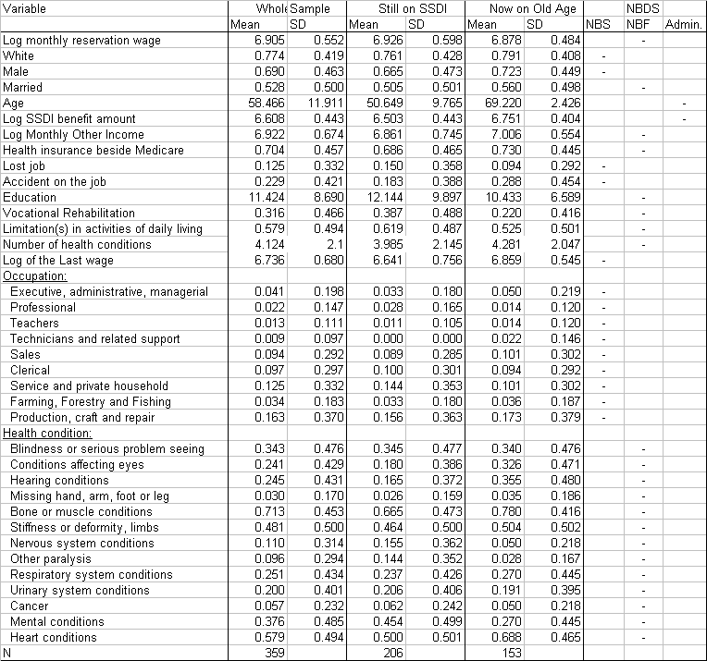

Source: Author’s calculations based on NBDS.
Table 4: Determinants of the Reservation Wage.
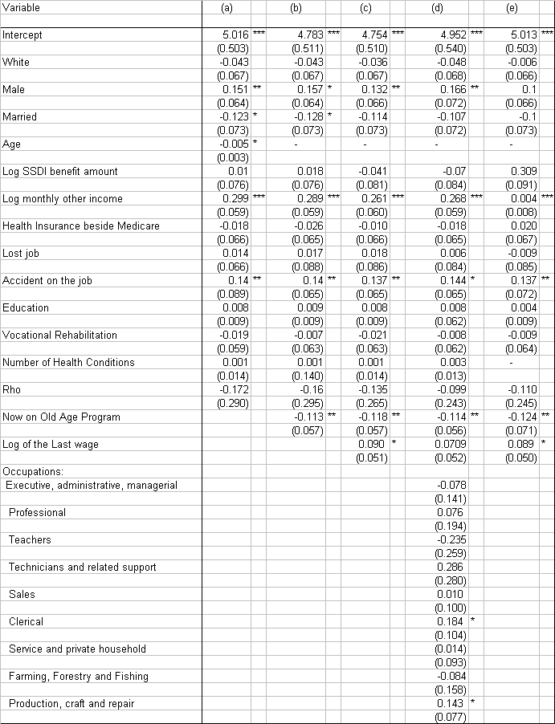

Table 4: Determinants of the Reservation Wage (Cont.)

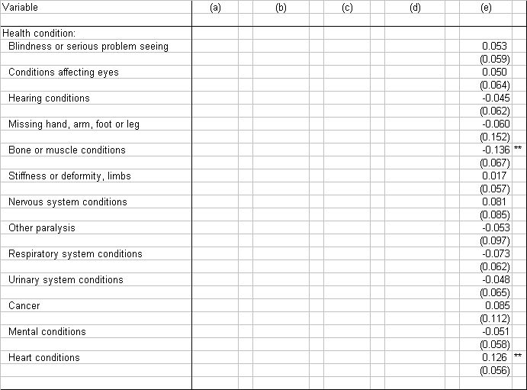
Note: Standard errors are in parentheses; ***, ** and * indicate significance at the 1%, 5% and 10% levels respectively.
Source: Author’s calculations based on NBDS.
Table 5: Determinants of the Reservation Wage on Sub-Samples

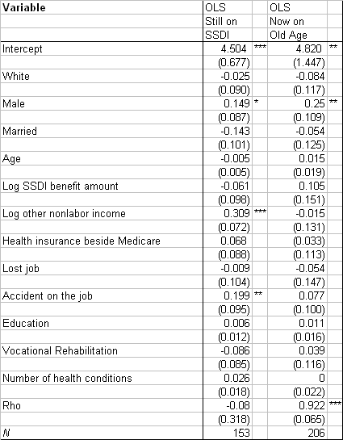
Note: Standard errors are in parentheses; ***, ** and * indicate significance at the 1%, 5% and 10% levels respectively.
Table 6: Descriptive Statistics on Job Search
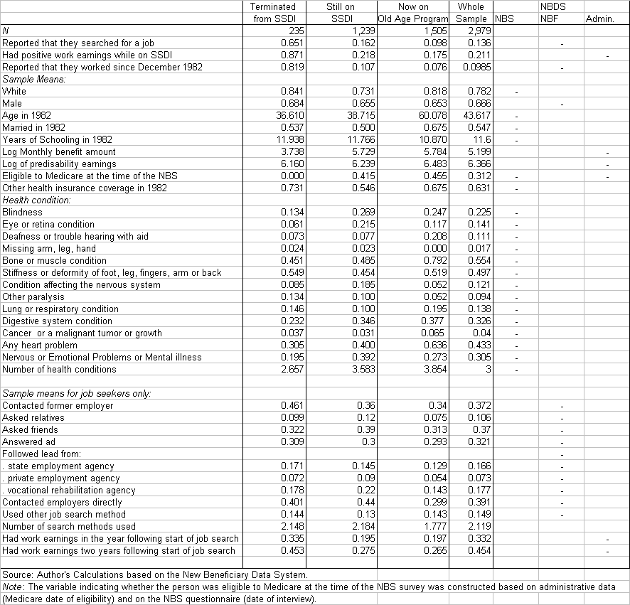
Table 7: Tobit Estimates of Job Search Efforts
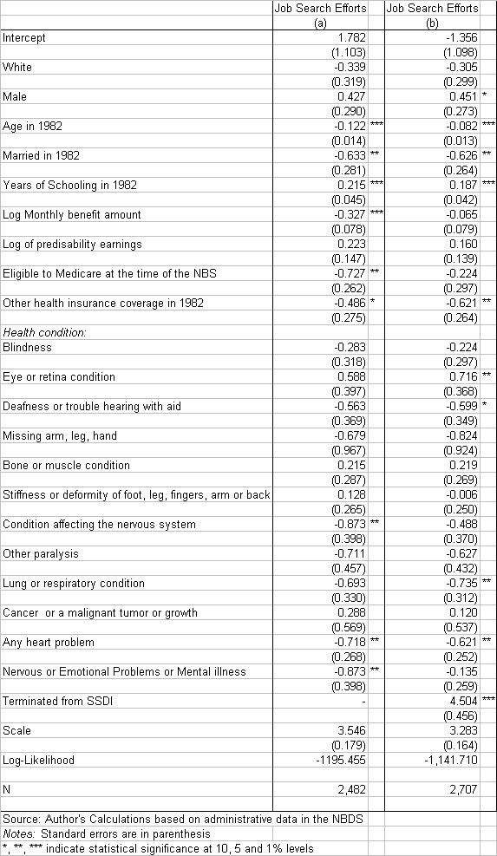
Table 8: Probit Estimates of Return to Work Outcomes
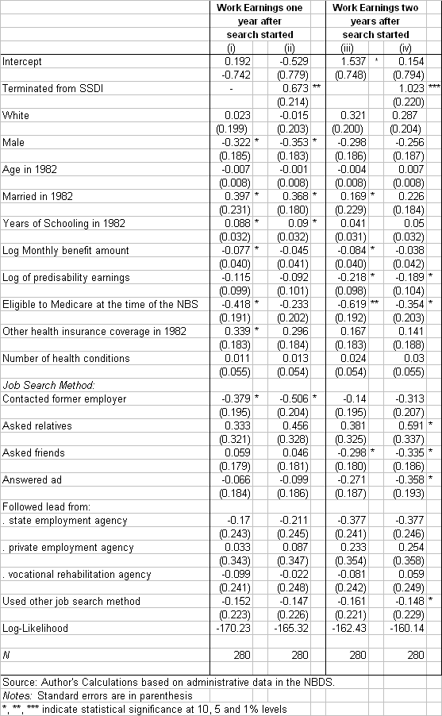

Table 9: Terminations due to Recovery and Return to Work

Figure 1: Terminations per 1,000 beneficiaries by reason, 1977-2002

Sources: SSA, Annual Statistical Report on the Social Security Disability Insurance Program, various years.
Figure 2: Mean Earnings and Percentage of Persons with Work Earnings by Termination Status

Source: Author’s Calculations based on the New Beneficiary Data System (administrative data).
Notes: Persons not terminated are persons who were still alive and on SSDI in 1991. The SSDI earnings limit is calculated as 12 times the monthly substantial gainful activity level.

Figure 3: Start of Job Search and Work Earnings for Terminated Beneficiaries

Source: Author’s Calculations based on the New Beneficiary Data System (administrative data and NBF).
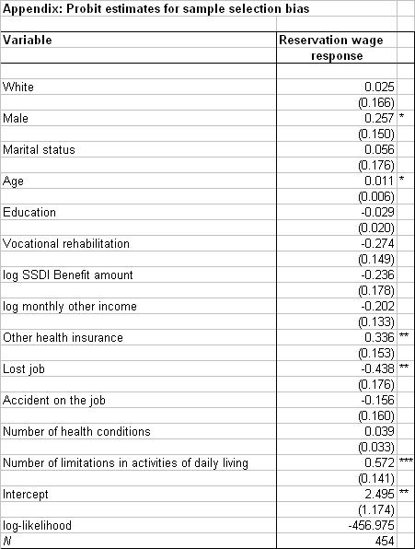
Note: Standard errors are in parentheses; ***, ** and * indicate significance at the 1%, 5% and 10% levels respectively.

While undertaking this project, Sophie Mitra was a researcher at the Program for Disability Research of the School of Management and Labor Relations at Rutgers, the State University of New Jersey. Sophie Mitra is now Assistant Professor, Department of Economics, Fordham University and can be contacted at Fordham University, 441 East Fordham Road, Bronx NY 10458-9993, Email: mitra@fordham.edu
A review of this literature can be found in Bound and Burkhauser (1999).
For instance, Gilbert and Parent (2003) provide an analysis of French and U.S. experiences.
Disability tagging system is meant in a broad sense and includes both the disability test at entry and CDRs.
They are also referred to as vocational rehabilitation services.
There is data on the wages of persons who worked since joining the rolls. It would be of interest to compare these wages to the reservation wages of persons who have not worked since becoming beneficiaries. However, this wage data is not used in this paper due to a lot of missing values.
The characteristics of this group and the determinants of whether a beneficiary worked or not was analyzed in detail in Muller (1992).
To be more precise, if work earnings are above the earnings limit, beneficiaries are not immediately terminated from SSDI, beneficiaries would have to meet certain conditions. First, beneficiaries can test their ability to work above the earnings limit without affecting their eligibility for benefits during a nine month long trial work period. After the trial work period ends, there is a three year period, the so-called extended period of eligibility (EPE), during which benefits are withheld for those months in which earnings exceed the earnings limit (SSA (2003a)). Once the EPE is over, the person’s SSDI benefit is terminated.
As of October 2000, SSDI beneficiaries who work above the earnings limit could receive Medicare Part A premium-free coverage for 93 months after the trial work period (SSA (2003a)).
Beneficiaries become eligible to Medicare two years after joining the SSDI rolls and coverage continues after they transition to the Old Age program.
If disability is understood as resulting from environmental factors, among others, then changes in the environment such as the passage of anti-discrimination laws, the availability of accessible transport system and physical environment could affect the reservation wages of persons with disabilities. This cannot be captured with the data set at hand.
Having a condition of the digestive system is used as a reference.
Contacting employers directly is used as a reference.
In the sample of terminated workers, there were 40, 91 and 68 medical recovery terminations in 1981, 1982 and 1983 respectively, and 21, 17, 19, 24, 11, 4, 14, and 3 for years 1984 through 1991 respectively.
The earnings limit is the annualized substantial gainful activity, i.e. $3,600 for years 1980 through 1989 and $6,000 for years 1990 and 1999.

